**Monitoring Tasks**

**1) Enable cloud trail monitoring and store the events in s3 and cloud watch log events.**

* Go to **AWS console**
* In search bar search **cloud trail**
* Go to **cloud trail service**
* Click on **create a trail**

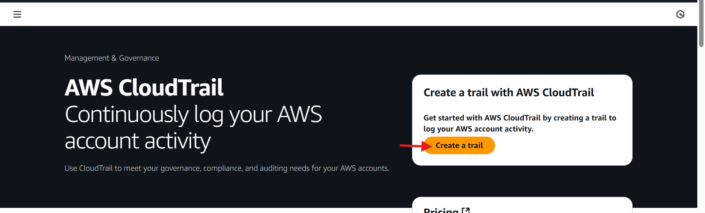

* Click on **create trail**

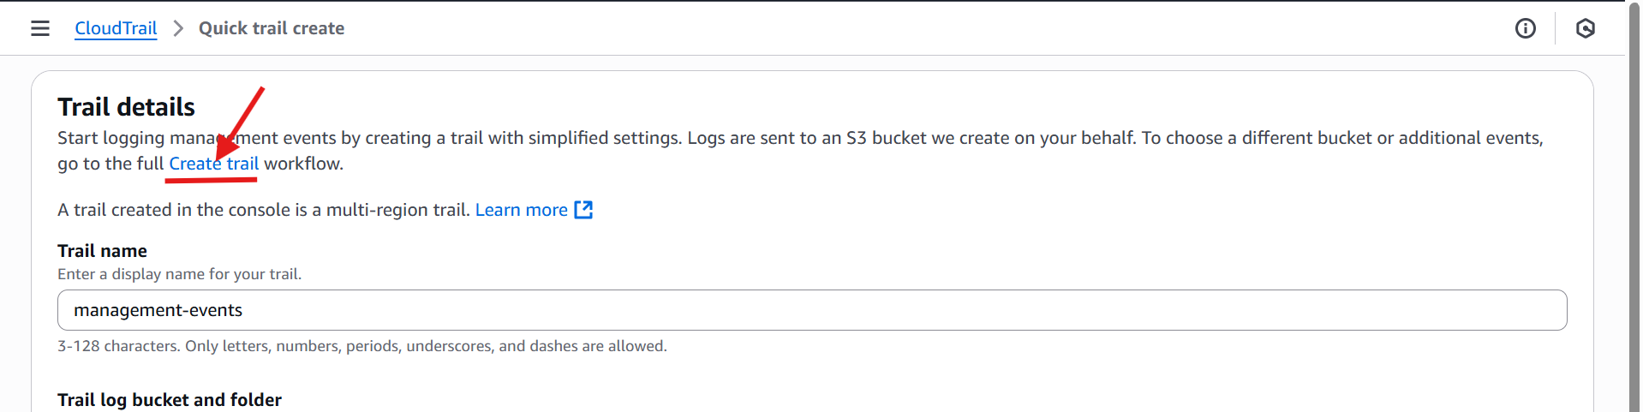

* Give **trail name (Deva-demo-trail)**
* Select **storage location** (create new s3 bucket)
* Disable the **Log file SSE-KMS encryption.**
* Enable **log file validation**
* Enable **SNS notification delivery**
* Create a new SNS notification and select existing one and give SNS topic.

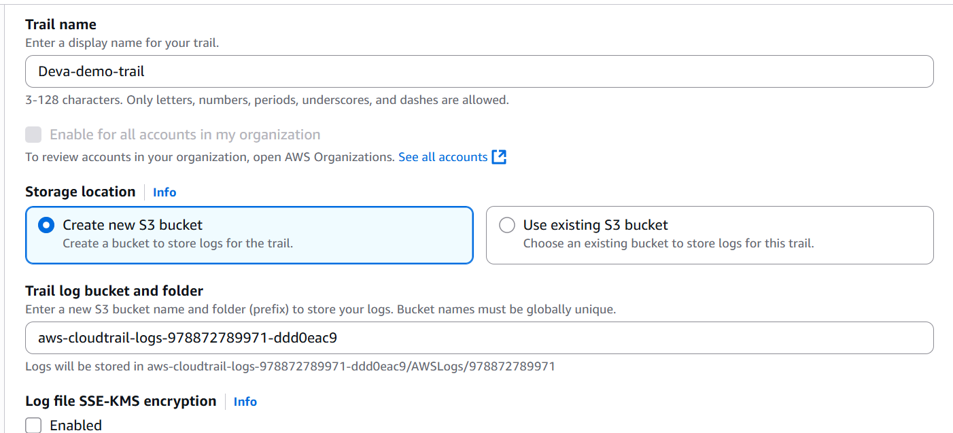

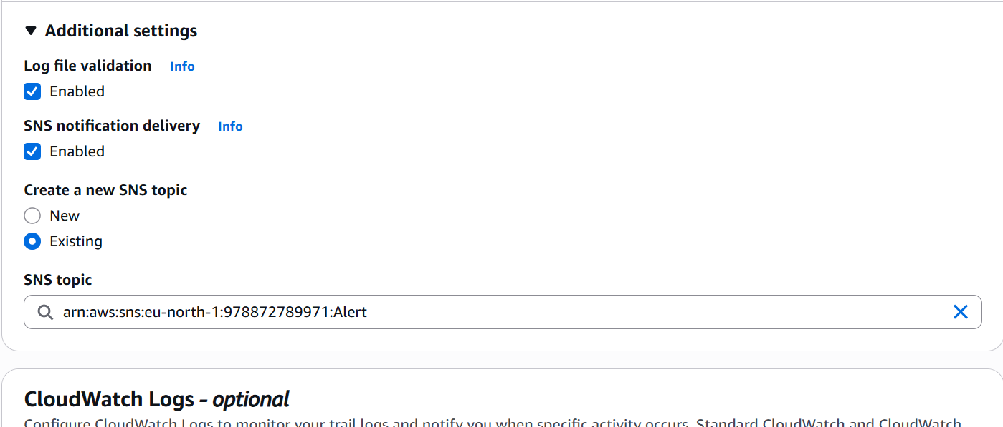

* Enable **cloud watch logs**
* Select **log group (New)**
* Select **IAM role new**
* Click on next

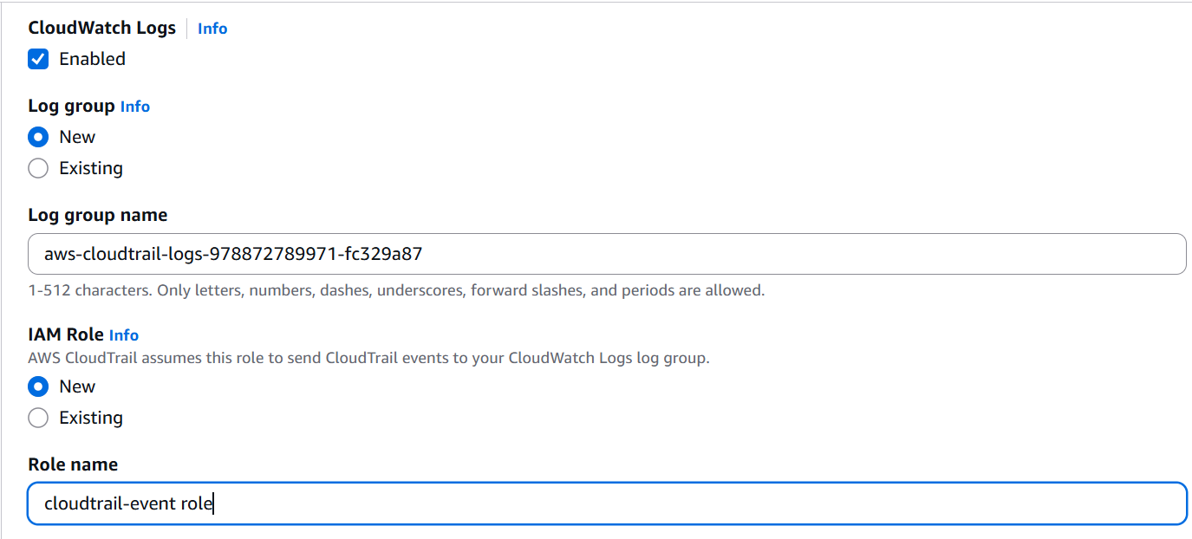

* Select event types -> **management events**
* Select **API activities read and write.**
* And click on **next.**

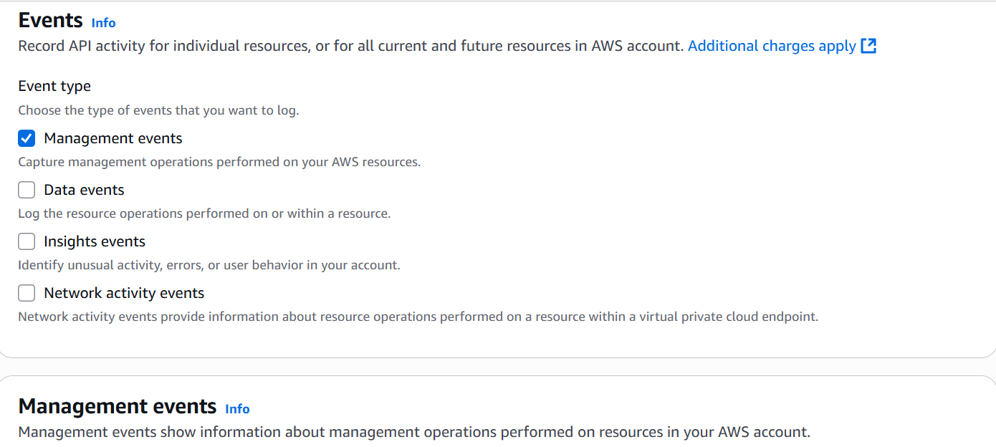

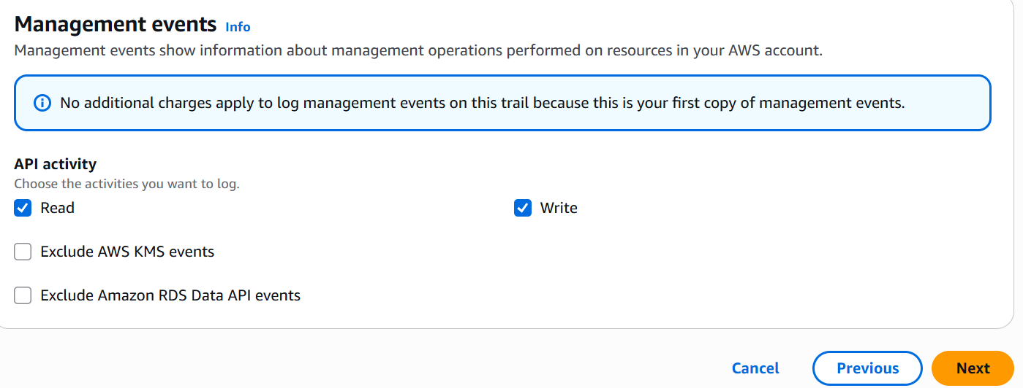

* Trail successfully created.

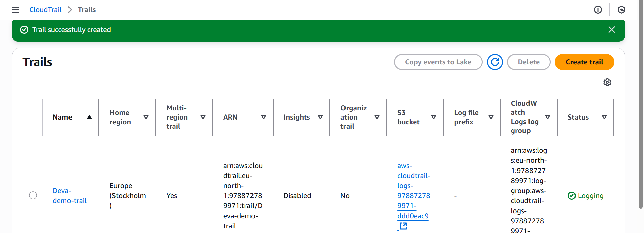

**2) Enable SNS for cloud trial to send alert on email.**

* Go to **AWS console**
* In search bar search **SNS (simple notification service).**
* Click on **next step.**

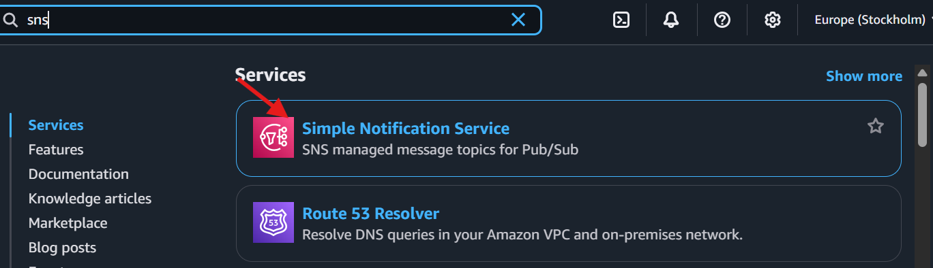

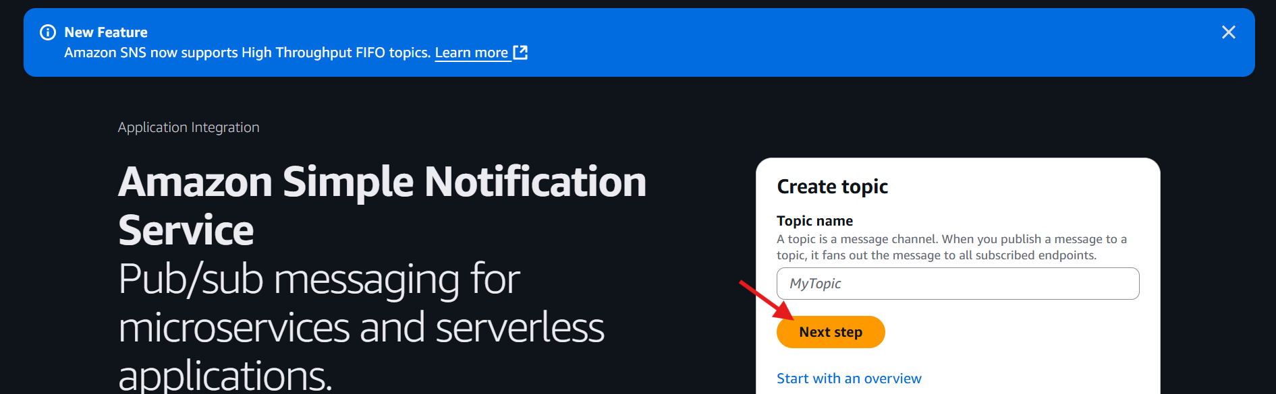

* Select **standard type**
* Give name (**Alert)**
* Give display name **(Cloud trail Alert)**
* Click on **create topic.**
* It will create one SNS alert.

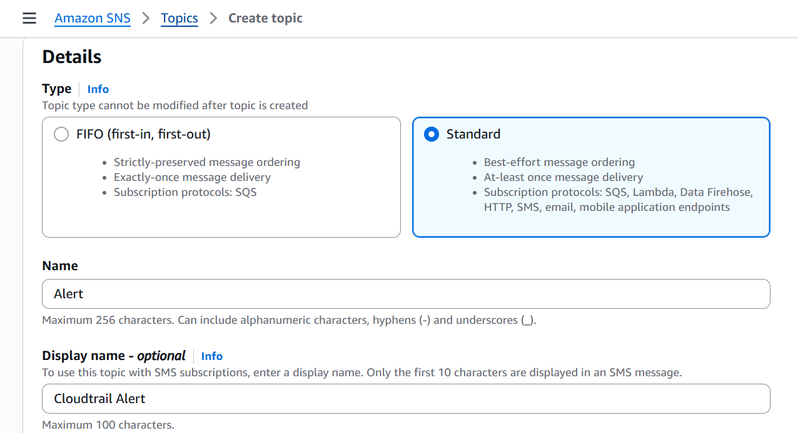

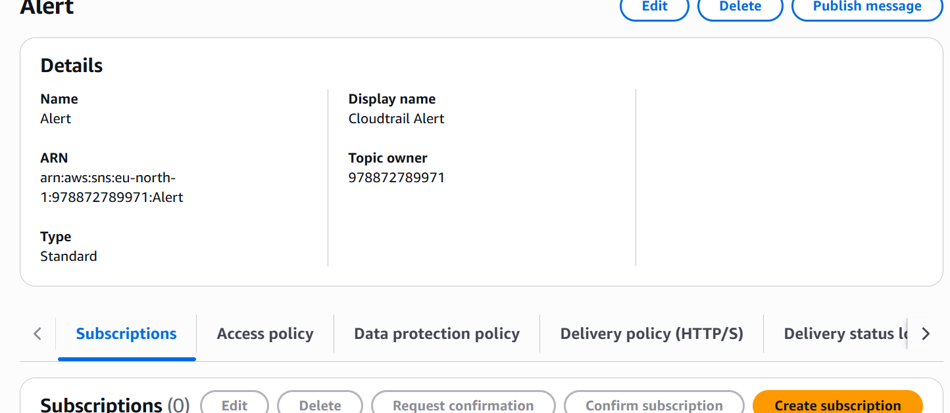

* Now to this particular topic, what kind of alert you want to configure.
* Click on **subscription**
* Click on **create subscription**
* In protocol, we can select SMS, email, etc…,
* Suppose you click on **SMS**, it will ask mobile number in endpoint.
* Suppose you click on **email**, it will asks email In endpoint
* Give email and click on **create subscription.**

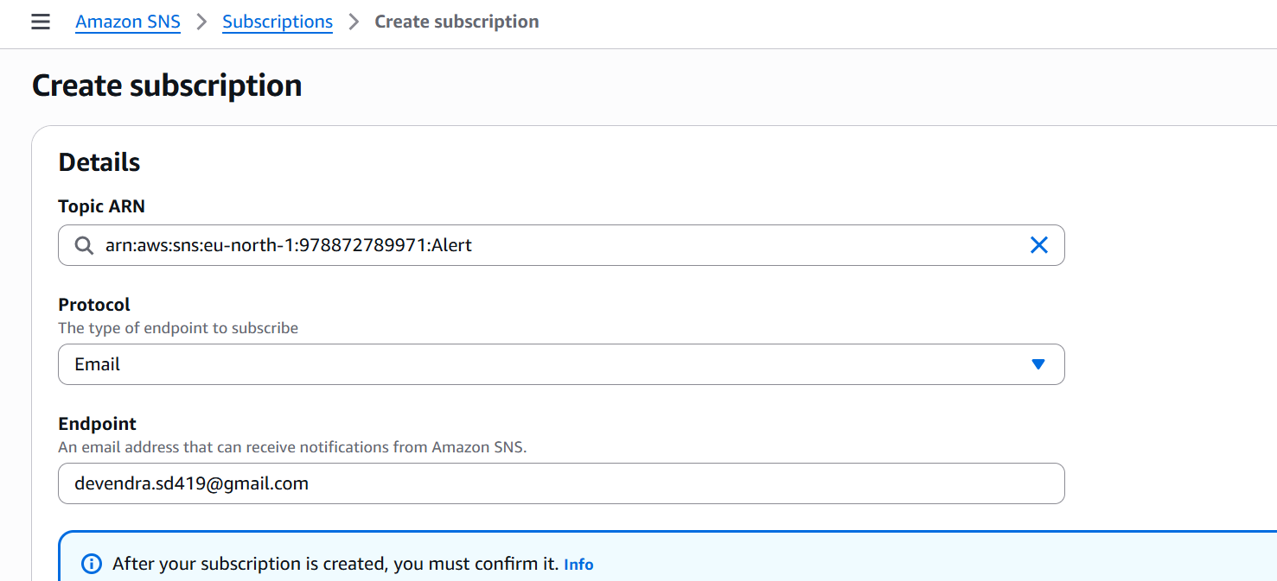

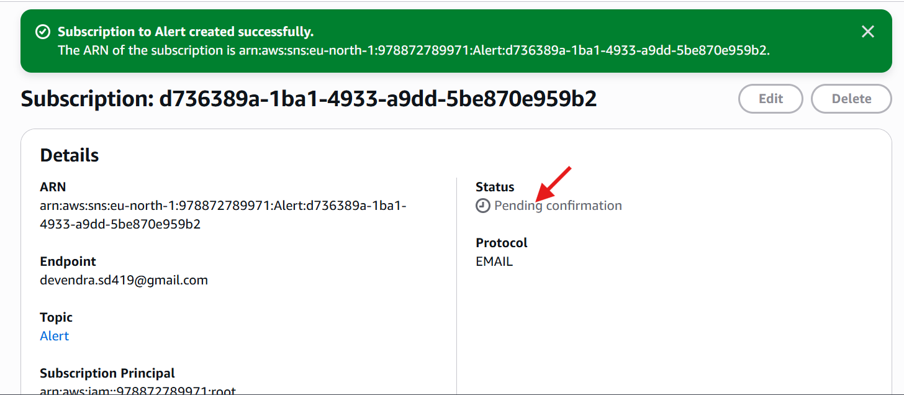

* Once the subscription has been created, it shows the status as **pending confirmation**.
* Means AWS sent an SNS notification to your email. Where we need to confirm that notification, then only the SNS subscription confirmed.

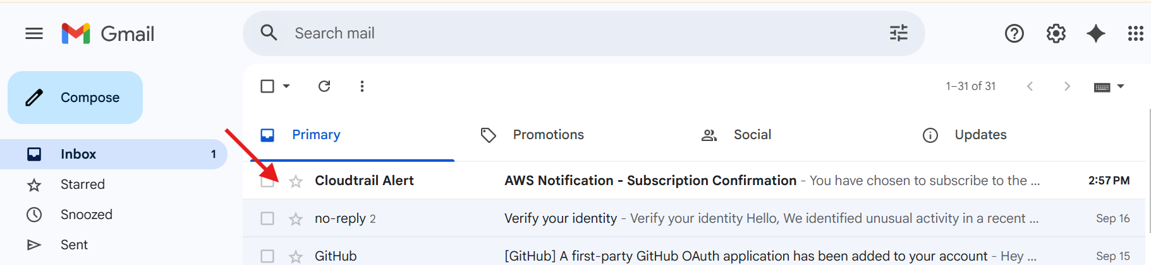

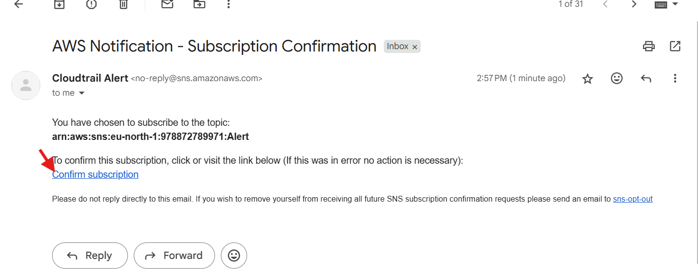

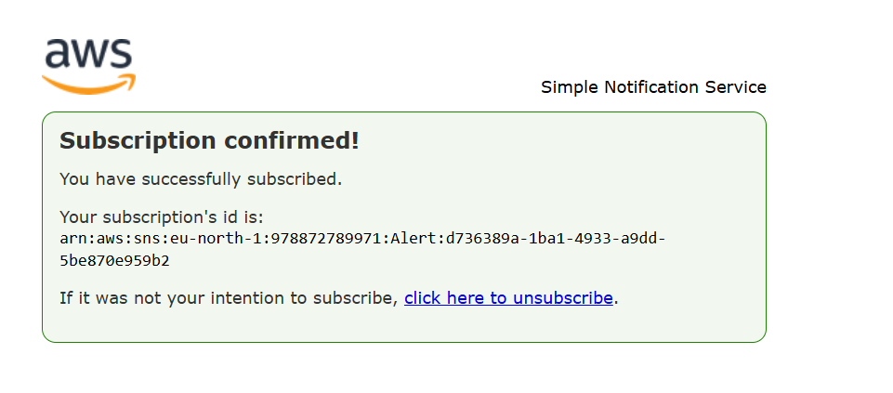

* Go to AWS SNS service and refresh the page, it shows status like **confirmed.**

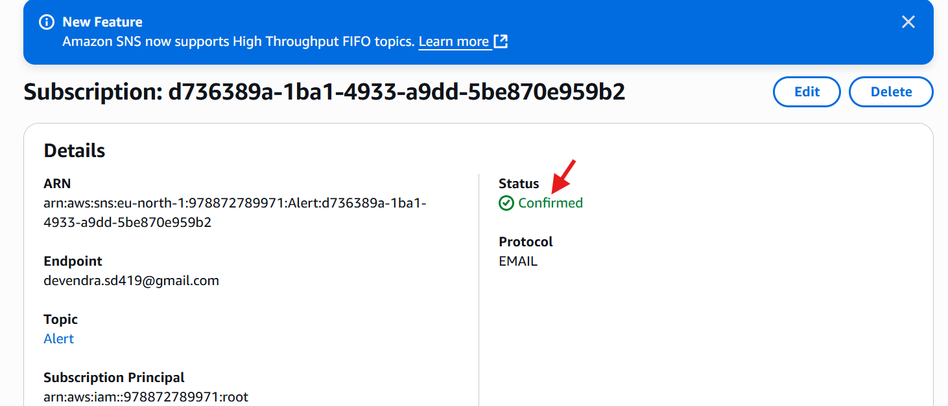

**3) Configure cloud watch monitoring and record the cpu utilization and other metrics of ec2.**

* Launch one instance

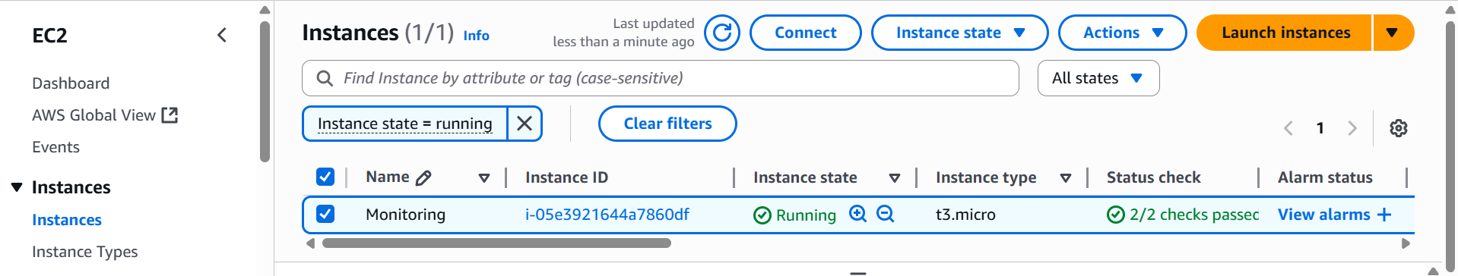

* Go to dash board
* Click on create dashboard
* Give name CPU utilization
* Add widget
* Select **ec2 instance**
* Select **per-instance metrics**

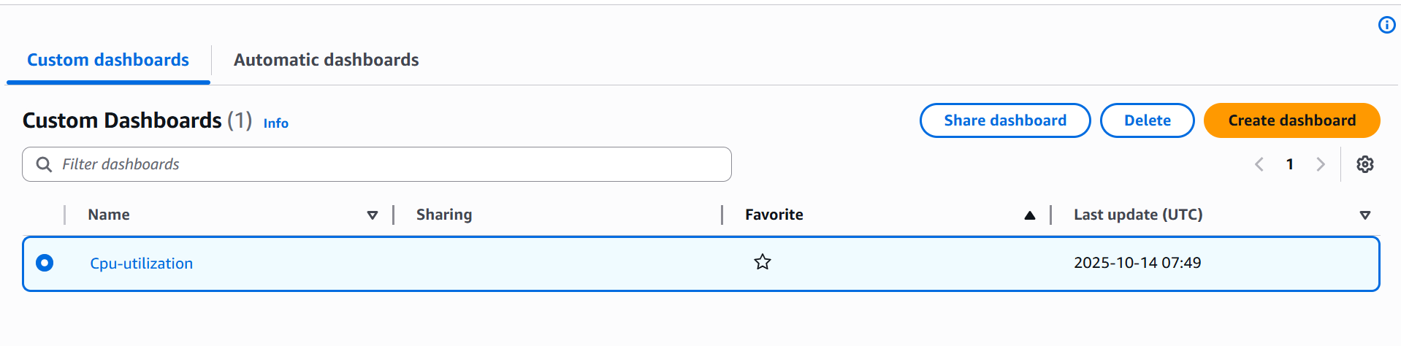

* Give instance id and select the cpu utilization

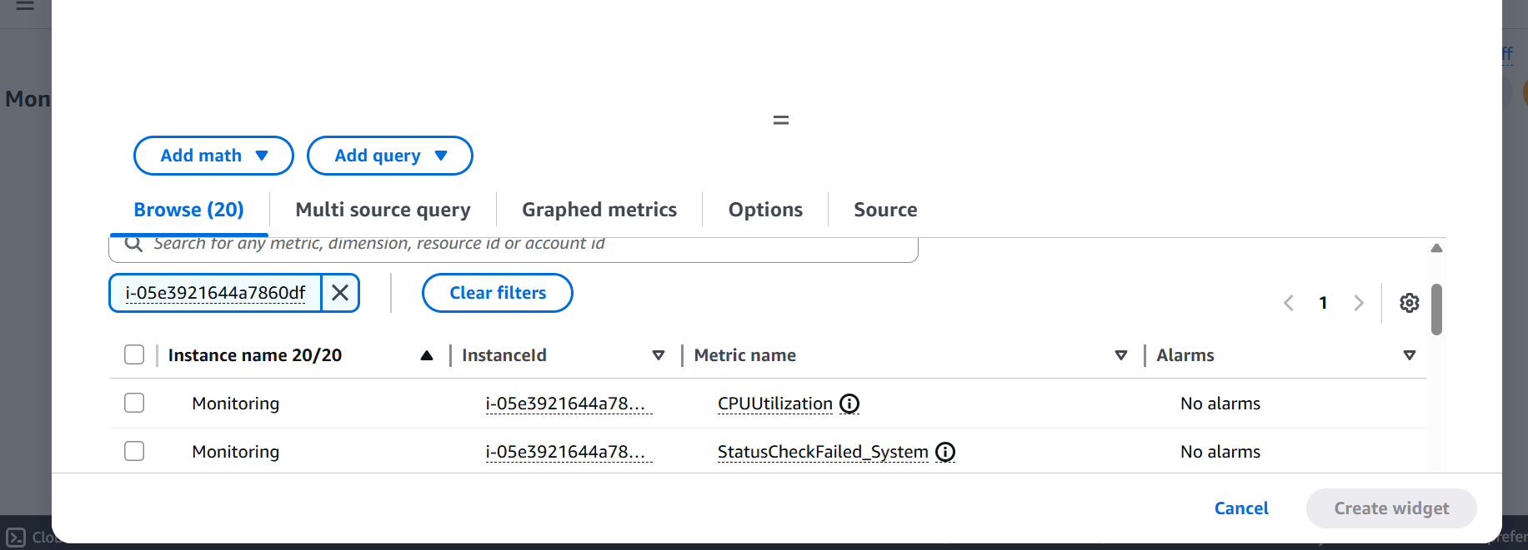

* Click on **create widget**

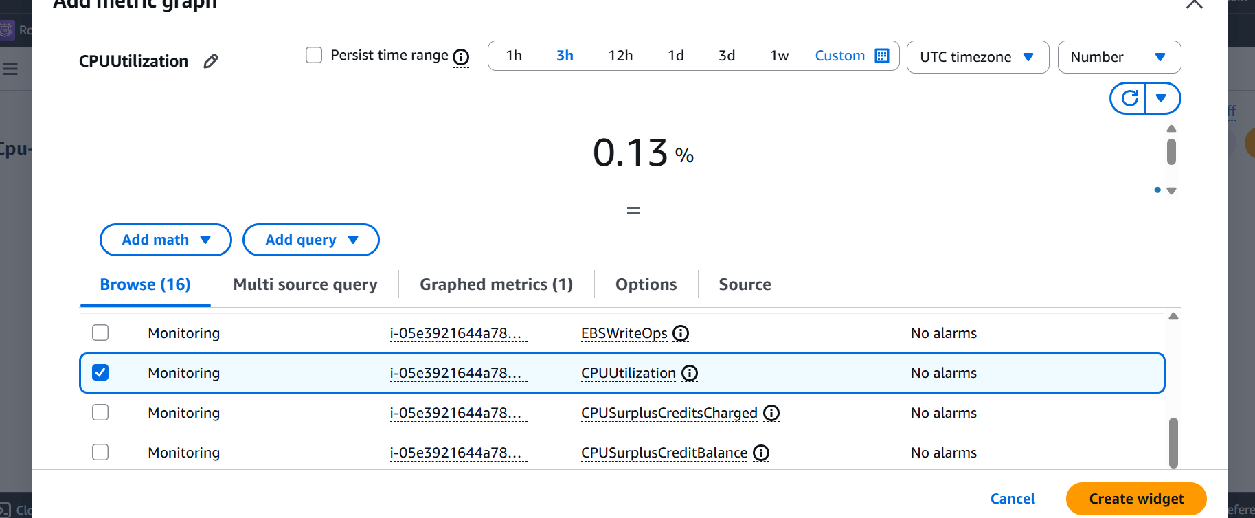

**4) Create one alarm to send alert to email if the cpu utilization is more than 70 percent.**

* Click on create alarm

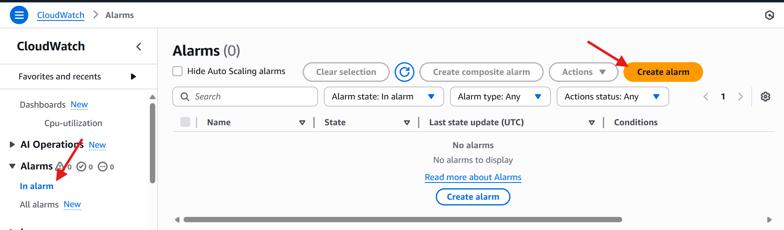

* Click on select metric 🡪click on next
* Select EC2 instance

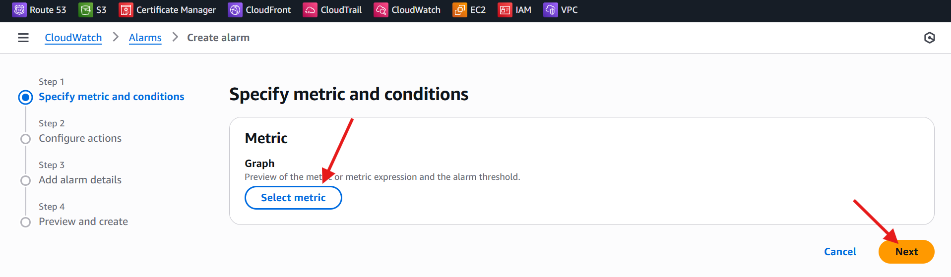

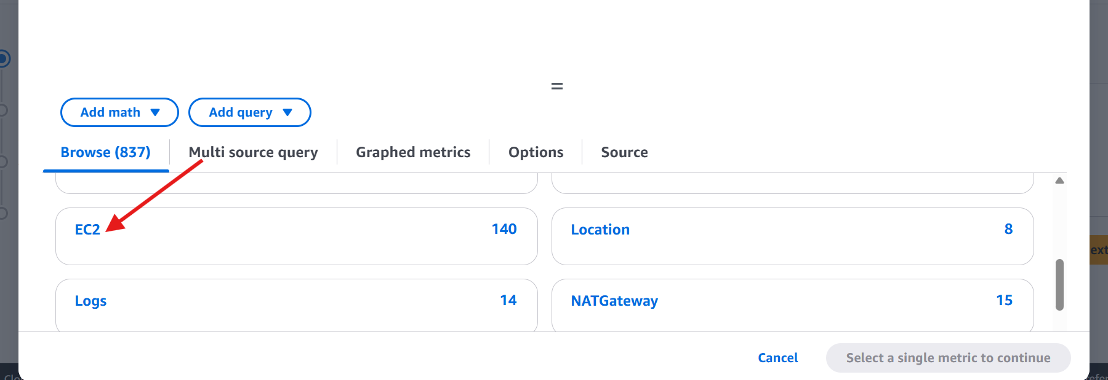

* Select the instance and select cpu utilization

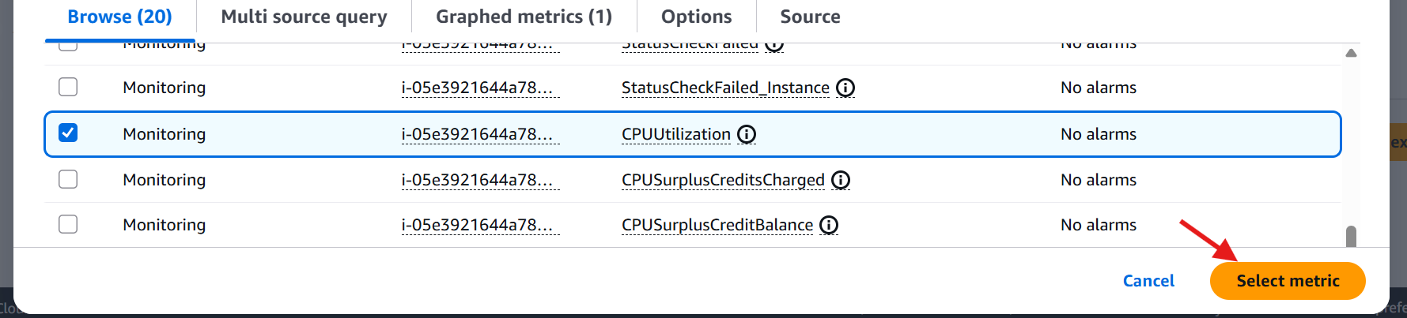

* Select static and select Greater threshold
* Give threshold value as 70
* Click on next.

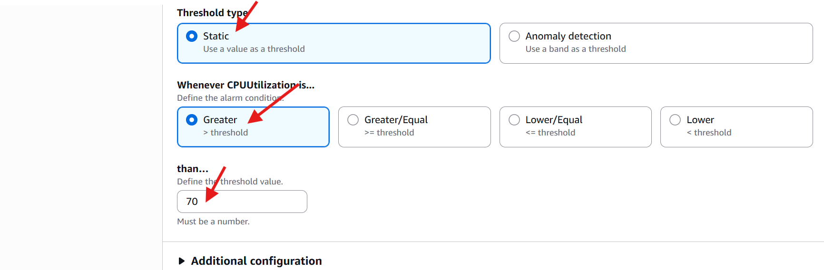

* Check your mail you got one mail
* If you want to give fake load use this command **yes > /dev/null &**

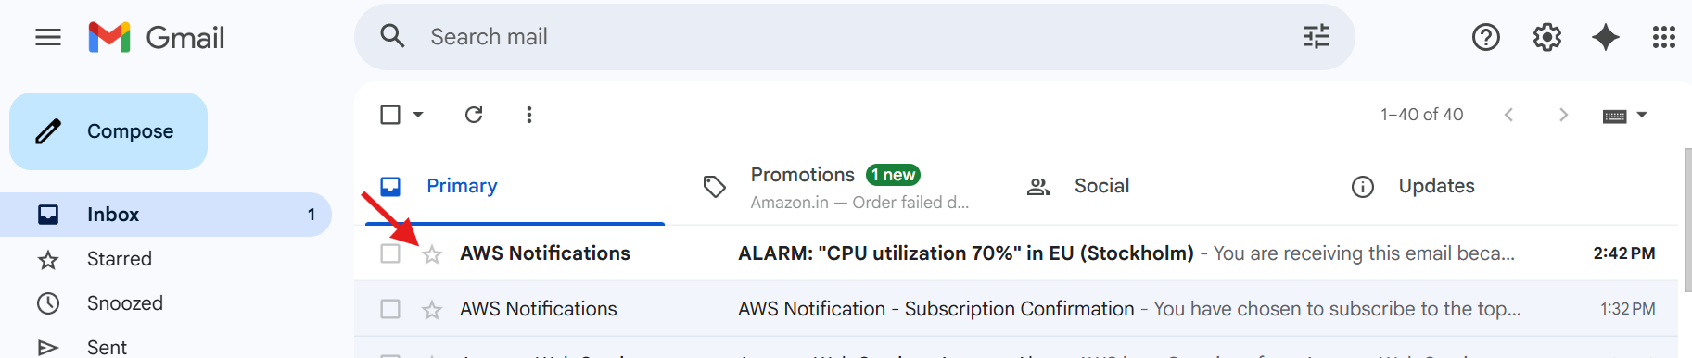

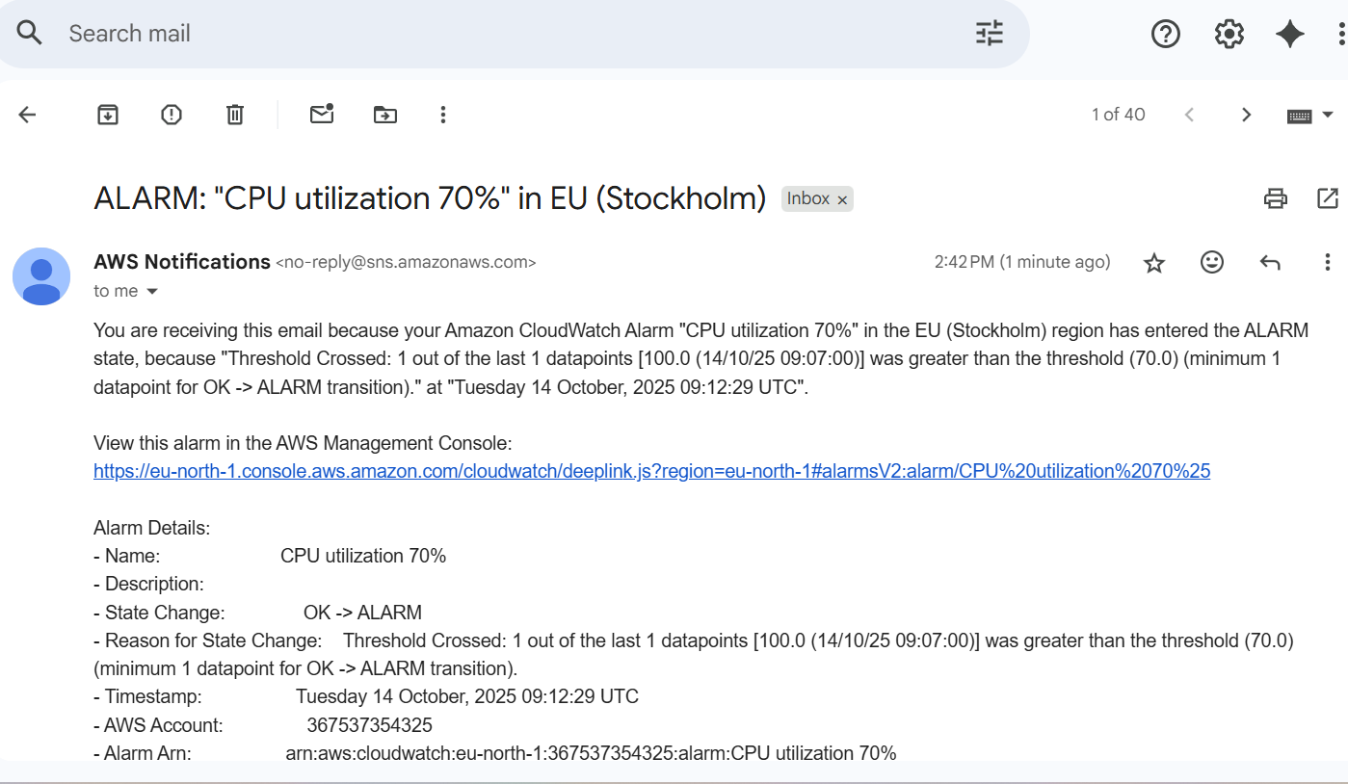

**5) Create Dashboard and monitor tomcat service whether it is running or not and send the alert.**

**6) Create Dashboard and monitor nginx service to send the alert if nginx is not running.**

* Download nginx
* Sudo yum install nginx -y

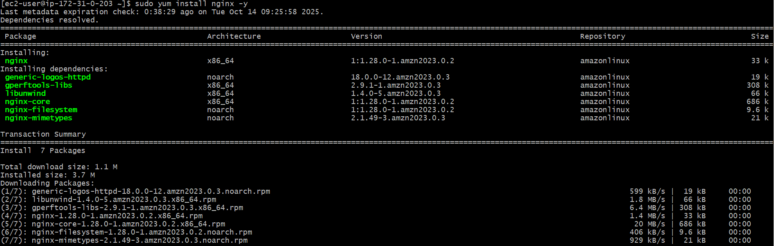

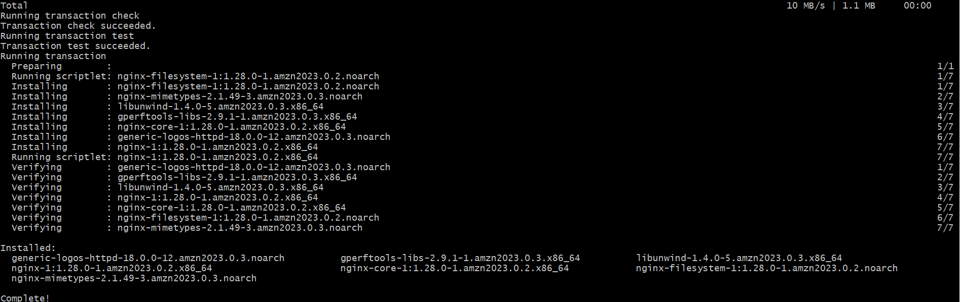

* Sudo systemctl status nginx
* Sudo systemctl start nginx
* Download crontabs **crontab -e**

